Supplementary Data
Disease classification | ICD 10 code
Acute Ischaemic Stroke | I63; I63.0; I63.1; I63.2; I63.3; I63.4; I63.5; I63.6; I63.8; I63.9
Intracerebral Haemorrhage | I61; I61.0; I61.1; I61.2; I61.3; I61.4; I61.5; I61.6; I61.8; I61.9
Stroke of undetermined pathology | I64
Heart Failure | I25.5; I42.0; I42.9; I50; I50.0; I50.1; I50.9; I51.7
Hypertension | I10; I11.0; I11.9; I12.0; I12.9; I15.1; I15.2; I15.8; I15.9;
Diabetes Mellitus | E10.9; E11.0; E11.2; E11.3; E11.4; E11.5; E11.6; E11.8; E11.9
Dyslipidaemia | E75.6; E78.0; E78.1; E78.2; E78.3; E78.4; E78.5; E78.6; E78.8; E78.9
Ischaemic Heart Disease | I20.0; I20.9; I25.0; I25.1; I25.2; I25.8; I25.9
Valvular Disease | I06.2; I061; I060; I05.2; I05.9; I05.1; I05.0; I07.1; I08.0; I08.1; I08.3; I09.9; I35.1; I35.2; I35.0; I34.2; I34.0; I34.1
Atrial Fibrillation | I48
Other Arrhythmias | I49.0; I49.1; I49.3; I49.4; I49.5; I49.8; I49.9; R00; R00.0; R00.1; R00.2
Peripheral Vascular Disease | I70.1; I70.2; I70.8; I70.9; I71.0; I71.2; I71.4; I71.9; I72.9; I73.9; I74.2; I74.3; I74.9; I77.1; I77.6
Cancers | C11.9; C18.9; C20; C22.0; C22.1; C34.9; C50.9; C53.9; C61; C67.9; C73; C77.9; C78.2; C79.3; C79.5; C79.8
Chronic Obstructive Pulmonary Disease | J42; J43.9; J44; J44.0
Chronic Kidney Disease | N18; N18.0; N18.1; N18.2; N18.3; N18.4; N18.5; N18.9; N19; Z99.2
Liver Disease | K70.1; K70.3; K71.2; K71.6; K72.0; K72.9; K74.6; K75.0; K75.8; K75.9; K76.0; K76.9; R18
Anaemia | D50.0; D50.8; D50.9; D52.9; D53.1; D53.9; D61.9; D62; D63; D63.0; D63.1; D63.8; D64.8; D64.9
Alcohol-related disorders | F10.0; F10.1; F10.2; F10.20
Neurodegenerative disorders | F03; F03.0; G31.0; G31.1; G31.9
Fever | R50.8; R50.9
Hyperglycaemia | R73.0; R73.9
Hypoglycaemia | E16.1; E16.2
Respiratory Failure | J96; J96.0; J96.1; J96.9
Pneumonia | J13; J14; J15; J15.0; J15.1; J15.2; J15.4; J15.5; J15.6; J15.8; J15.9; J18; J18.0; J18.1; J18.2; J18.8; J18.9; J22
Sepsis | A02.1; A40.1; A40.8; A40.9; A41; A41.0; A41.1; A41.2; A41.5; A41.8; A41.9; B37.7; E02; R65.2
Shock | R57; R57.0; R57.1; R57.8; R57.9
Myocardial Infarction | I21; I21.0I21.4; I21.1; I21.2; I21.3; I22.9; I24.9
Acute Kidney Injury | N10; N17; N17.0; N17.8; N17.9
Coma | E15; R40.2
Pulmonary Oedema | J81
Procedure | ICD 9 code
Mechanical Ventilation | 9390; 9670; 9671; 9672
Tracheostomy | 311; 3129
Gastrostomy | 4311
Thrombolysis | 9910
Echocardiography | 8872
Supplementary Table 1. International Classification of Disease codes utilised in extracting the data regarding the listed co-morbidities, complications and procedures from the insurance database.

 | Death in hospital
 | OR [99%CI] | P value
All strokes | 1.86 [1.78-1.93] | < 0.001
Acute Ischemic Stroke | 2.46 [2.34-2.58] | < 0.001
Intracerebral Haemorrhage | 1.47 [1.35-1.60] | < 0.001
Stroke of undetermined pathology | 1.92 [1.62-2.28] | < 0.001

Supplementary Table 2. Influence of pre-existing Heart Failure on stroke mortality in hospital (results of multivariable logistic regression with no HF as reference category; adjustments restricted to age, sex, co-morbid cardiovascular disease (hypertension, diabetes mellitus, dyslipidaemia, ischaemic heart disease, valvular disease, atrial fibrillation, other arrhythmias and peripheral vascular disease) and cancers. Results in bold are statistically significant (P < 0.01).

 | Acute Ischaemic Stroke | Intracerebral Haemorrhage | Stroke of undetermined pathology
Age
Sex | * |  | *
Heart Failure |  | **
Hypertension | * |  | *
Diabetes Mellitus | * | * | *
Dyslipidaemia
Ischaemic Heart Disease |  |  | *
Valvular disease
Atrial Fibrillation
Arrhythmias |  | * | *
Peripheral Vascular Disease
Cancers
Chronic Obstructive Pulmonary Disease
Chronic Kidney Disease
Liver Disease
Anaemia
Alcohol-related disorders | * | * | *
Neurodegenerative disorders |  | *
Fever |  | *
Hyperglycaemia | *
Hypoglycaemia |  | *

Supplementary Table 3. Co-variates included in the multivariable models with the outcome of long-term mortality.*Variable was found to be non-concordant with the proportional hazards assumption and was modelled as a non-constant function of time using the Weibull distribution. ** Variable was found to be non-concordant with the proportional hazards assumption and was modelled as a non-constant function of time using restricted cubic splines with 5 degrees of freedom.

 | HF (10 year - Survival [99%CI]) | No HF (10 year -Survival [99%CI])
Ischaemic | 17.92% [17.24% - 18.63%] | 37.28% [36.93% - 37.65%]
Haemorrhagic | 18.87% [16.63% - 21.41%] | 38.6% [38.07% - 39.08%]
Undetermined | 15.72% [14.30% - 17.27%] | 34.78% [34.15% - 35.42%]

Supplementary Table 4. Predicted values of the survival functions (presented as point estimates and 99% confidence interval values) for stroke type calculated for patients with and without co-morbid HF.

 | AIS | ICH
Transition | HR[99% CI] | HR[99% CI]
Baseline – Recurrent stroke | * | *
Baseline – death | 1.69[1.64-1.74] | *
Recurrent stroke – death | 1.45[1.34-1.57] | 1.28[0.99-1.66]

*Hazard Ratio modelled as a function of time due to non-concordance with the proportional hazard assumption. Graph of the function illustrated in Figure 6
Supplementary Table 5. Hazard Ratios of each transition, calculated for patients with HF (with no HF as reference).

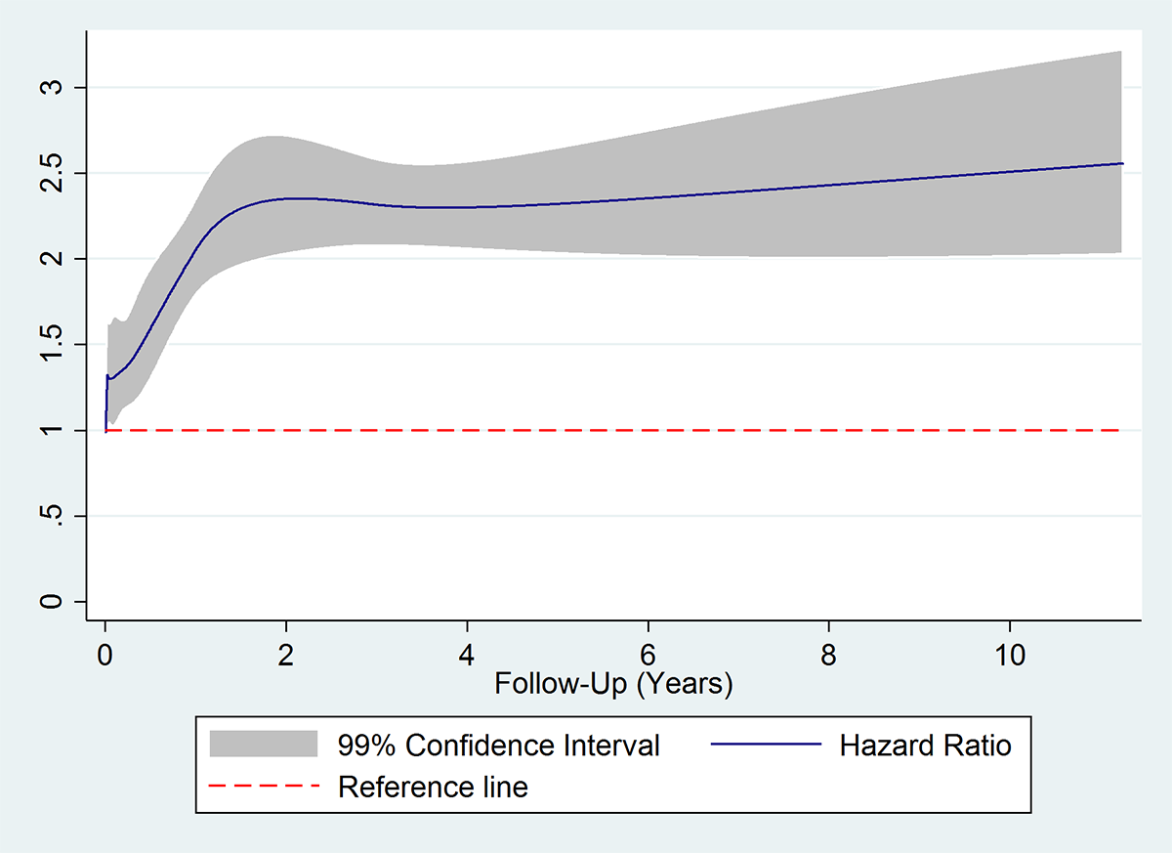

Supplementary Figure 1. The hazard ratio (HR) calculated for patients with intracerebral haemorrhage and co-morbid heart failure (with no heart failure as the reference category). The solid line represents the point estimate, whilst the shaded area is bound by the extreme values of the 99% confidence interval

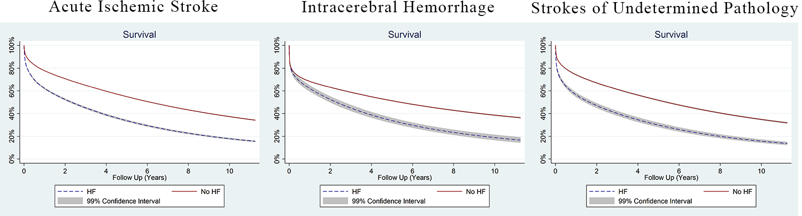

Supplementary Figure 2. Predicted survival probability stratified by HF status. Separate calculations were performed for each stroke type. The solid line represents the point estimates in patients without co-morbid heart failure, whilst the dashed line represents the point estimates in patients with co-morbid heart failure. The shaded areas are bound by the extreme values of the 99% confidence interval for each respective point estimate

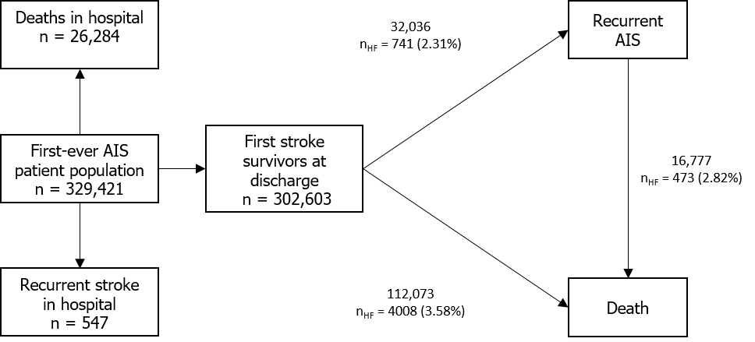
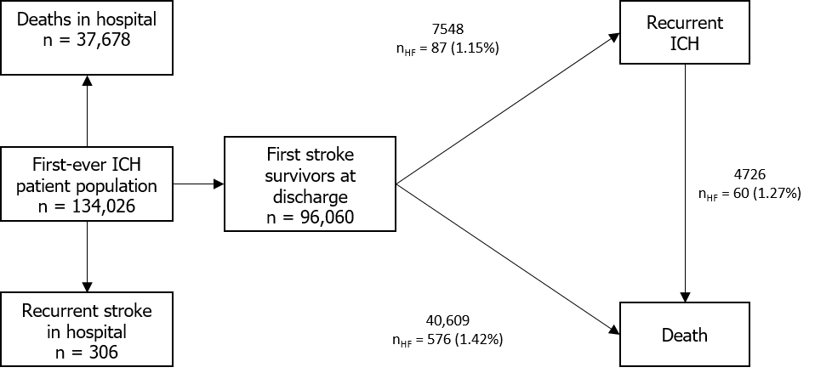
Supplementary Figure 3. Flowchart of first-ever stroke patients admitted with Acute Ischemic Stroke (AIS) and Intracranial Haemorrhage (ICH) respectively.
Supplementary Figure 4. Results of the sensitivity multi-state analysis adjusting only for age, sex, co-morbid cardiovascular disease (hypertension, diabetes mellitus, dyslipidaemia, ischaemic heart disease, valvular disease, atrial fibrillation, other arrhythmias and peripheral vascular disease) and cancers. Hazard Ratio (HR) functions were plotted against the post-discharge follow-up time. The solid line represents the point estimate, whilst the shaded area is bound by the limits of the 99% confidence interval. The dashed line represents the reference line (HR = 1).

